CHEM 1021 — Exam 3 Practice Test
Day 3 of 7
Date: ______________________ Score: ________ / 100
Instructions: 25 multiple-choice questions, 4 points each. Choose the single best answer. Give yourself 50 minutes. Use only the reference information below, a periodic table, and a calculator. Fill in the answer sheet on the last page, then grade with the Day 3 Answer Key.
Reference Information
Equations and constants: Molarity = moles solute ÷ liters of solution · M₁V₁ = M₂V₂ · Nₐ = 6.022 × 10²³ · 1 cm³ = 1 mL · 1 L = 1 dm³ · 0.3047 m = 1 ft
The 7 strong acids: HCl, HBr, HI, H₂SO₄, HNO₃, HClO₄, HClO₃. Strong bases: all soluble hydroxide salts.
Common polyatomic ions: ammonium NH₄⁺ · hydronium H₃O⁺ · hydroxide OH⁻ · cyanide CN⁻ · carbonate CO₃²⁻ · phosphate PO₄³⁻ · chlorate ClO₃⁻ · bromate BrO₃⁻ · iodate IO₃⁻ · sulfate SO₄²⁻ · selenate SeO₄²⁻ · nitrate NO₃⁻ · acetate CH₃CO₂⁻
Acid naming: no oxygen → hydro- + root + -ic acid · -ate ion → -ic acid · -ite ion (one fewer O) → -ous acid · one more O than the -ate → per- + root + -ic acid · one fewer O than the -ite → hypo- + root + -ous acid
Activity Series (most → least active; a metal displaces any metal ion listed below it)
Group | Metals | Reacts with
1 | K, Ba, Sr, Ca, Na | Cold water, steam, and acids (produce H₂)
2 | Mg, Al, Mn, Zn, Cr, Fe, Cd | Steam and acids (produce H₂)
3 | Co, Ni, Sn, Pb | Acids only (produce H₂)
— | H₂ | —
4 | Sb, Bi, Cu, Ag, Hg, Pd, Pt | Do not react with water, steam, or acids
Electronegativity (main-group values)
Period | 1 | 2 | 13 | 14 | 15 | 16 | 17
1 | H 2.1
2 | Li 1.0 | Be 1.5 | B 2.0 | C 2.5 | N 3.0 | O 3.5 | F 4.0
3 | Na 0.9 | Mg 1.2 | Al 1.5 | Si 1.8 | P 2.1 | S 2.5 | Cl 3.0
4 | K 0.8 | Ca 1.0 | Ga 1.6 | Ge 1.8 | As 2.0 | Se 2.4 | Br 2.8
5 | Rb 0.8 | Sr 1.0 | In 1.7 | Sn 1.8 | Sb 1.9 | Te 2.1 | I 2.5
Solubility Rules
Ion | Rule | Exceptions
Na⁺, K⁺, NH₄⁺ | Salts with an alkali metal or ammonium ion are soluble | None
NO₃⁻, CH₃CO₂⁻ | All nitrates and acetates are soluble | None
SO₄²⁻ | Most sulfates are soluble | BaSO₄, SrSO₄, PbSO₄, CaSO₄, Hg₂SO₄, Ag₂SO₄
Cl⁻, Br⁻, I⁻ | Most chlorides, bromides, and iodides are soluble | AgX, Hg₂X₂, PbX₂, HgI₂
Ag⁺ | Silver compounds are generally insoluble | AgNO₃ and AgClO₄ are soluble; AgCH₃CO₂ is slightly soluble
O²⁻, OH⁻ | Oxides and hydroxides are insoluble | Alkali metal hydroxides, Ba(OH)₂, Sr(OH)₂; Ca(OH)₂ is somewhat soluble
S²⁻ | Sulfides are insoluble | Compounds with Na⁺, K⁺, NH₄⁺, and alkaline earth cations
CrO₄²⁻ | Most chromates are insoluble | Compounds with Na⁺, K⁺, NH₄⁺, Mg²⁺, Ca²⁺, Al³⁺, Ni²⁺
CO₃²⁻, PO₄³⁻, SO₃²⁻, SiO₃²⁻ | Most carbonates, phosphates, sulfites, and silicates are insoluble | Compounds with Na⁺, K⁺, NH₄⁺

1. Returning Topic: Report the answer to the following calculation with the correct number of significant figures:
(25.0 + 1.236) × 0.0402
A. 1.0
B. 1.05
C. 1.055
D. 1.0547
2. Returning Topic: How many square meters are there in 4.70 square kilometers?
A. 4.70 × 10⁻³ m²
B. 4.70 × 10³ m²
C. 4.70 × 10⁶ m²
D. 4.70 × 10⁹ m²
3. Returning Topic: Consider the transition metal nickel (Z = 28). How many d electrons are in the ground-state electron configuration of the Ni²⁺ ion?
A. 2
B. 6
C. 8
D. 10
4. Returning Topic: Which of the following is the correct electron configuration for a neutral silver (Z = 47) atom?
A. [Kr]5s¹4d¹⁰
B. [Kr]5s²4d⁹
C. [Kr]5s²5d⁹
D. [Kr]4d¹¹
5. Iron forms the following compound with bromine: FeBr₃. What is the name of this compound?
A. iron tribromide
B. iron(III) bromide
C. iron(I) tribromide
D. iron bromide
6. Which of the following ions would form the strongest bond with a fluoride ion?
A. Li⁺
B. Na⁺
C. Cs⁺
D. K⁺
7. Consider the compound SF₆. What is the correct name for this compound?
A. sulfur fluoride
B. monosulfur hexafluoride
C. sulfur hexafluoride
D. sulfur(VI) fluoride
8. The element blixium reacts with marnium to form a compound with the name tetrablixium monomarnide. Which of the following statements about this compound is correct?
A. Blixium is a metal.
B. The compound is ionic.
C. The compound contains four times as many marnium atoms as blixium atoms.
D. Blixium is further left or below marnium on the periodic table.
9. Categorize the following compounds as ionic or covalent.
I: NH₄Cl II: CO₂ III: MgO
A. I is ionic; II and III are covalent.
B. III is ionic; I and II are covalent.
C. I and III are ionic; II is covalent.
D. I, II, and III are all covalent.
10. Which of the following bonds is least polar? (Use the electronegativity table.)
A. N–H
B. C–S
C. B–F
D. Si–O
11. What is the electron domain geometry on the atom X in the structure shown?
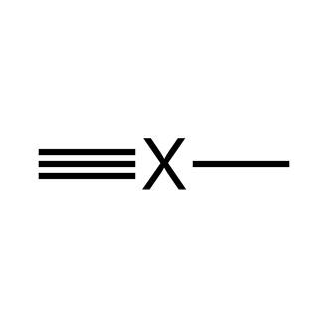
A. Linear
B. Trigonal planar
C. Tetrahedral
D. Bent
12. Predict the molecular shape and the approximate bond angle of methane, CH₄.
A. Tetrahedral, < 109.5°
B. Tetrahedral, 109.5°
C. Square planar, 90°
D. Trigonal pyramidal, < 109.5°
13. Ozone, O₃, exhibits resonance. The first resonance structure is shown. Which structure is another valid resonance structure for ozone?
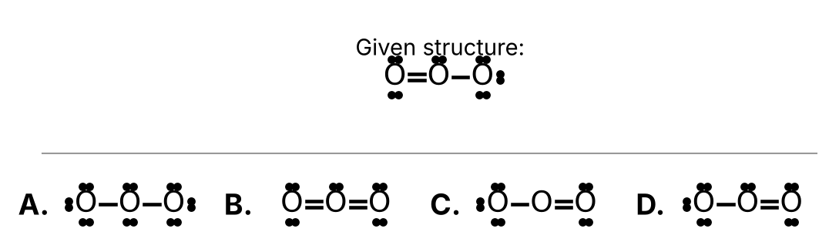
Choose A, B, C, or D from the figure.
14. You prepare an aqueous solution of silver nitrate. Which of the following statements about this solution is correct?
A. The solvent is water and the solute is AgNO₃.
B. The solvent is AgNO₃ and the solute is water.
C. The solvent is water and the solute is AgNO₂.
D. The solvent is water and the solute is SiNO₃.
15. A solution is made by dissolving 0.0450 moles of KCl in enough water to make 300.0 mL of solution. What is the molarity?
A. 1.50 × 10⁻⁴ M
B. 0.0135 M
C. 0.150 M
D. 6.67 M
16. Use the solubility rules to determine which of the following compounds is not soluble in water.
A. Mg(NO₃)₂
B. Fe(OH)₃
C. Na₂SO₄
D. (NH₄)₂CO₃
17. Glimmer (Gm) is a fictional non-metal that forms an acid with the formula H₂Gm. What is the name of this compound?
A. Glimmeric acid
B. Hydroglimmerous acid
C. Glimmerous acid
D. Hydroglimmeric acid
18. Quintium (Qt) is a fictional element that forms the polyatomic ion named quintate with the formula QtO₄²⁻. What would be the name of the acid with the chemical formula H₂QtO₄?
A. Quintous acid
B. Hydroquintic acid
C. Quintic acid
D. Perquintic acid
19. Which of the following soluble compounds when dissolved in water will not create an electrolyte solution?
A. H₂SO₄
B. NaNO₃
C. CaCl₂
D. CH₃OH
20. Consider the following chemical reaction:
Zn (s) + 2 HCl (aq) → ZnCl₂ (aq) + H₂ (g)
Which of the following statements about this reaction is incorrect?
A. Zinc is a reactant.
B. A gas is produced.
C. ZnCl₂ is a product.
D. All of the reactants and products are dissolved in water.
21. Balance the following chemical equation:
Al (s) + O₂ (g) → Al₂O₃ (s) (unbalanced)
How many atoms of oxygen are found on the product side when the equation is properly balanced?
A. 3
B. 4
C. 6
D. 12
22. Diboron hexahydride gas reacts with oxygen gas to produce diboron trioxide and water vapor. Write a properly balanced chemical equation for this reaction. How many oxygen molecules are consumed in this reaction?
A. 2
B. 3
C. 6
D. 9
23. Consider the following chemical reaction:
P₄ + 5 O₂ → P₄O₁₀
This reaction would be classified as a ____.
A. Single Displacement Reaction
B. Double Displacement Reaction
C. Synthesis (Combination) Reaction
D. Decomposition Reaction
24. Which of the following chemical reactions will occur?
A. Ni (s) + 2 AgNO₃ (aq) → Ni(NO₃)₂ (aq) + 2 Ag (s)
B. Pb (s) + MgCl₂ (aq) → PbCl₂ (aq) + Mg (s)
C. Sn (s) + ZnSO₄ (aq) → SnSO₄ (aq) + Zn (s)
D. Cu (s) + 2 HCl (aq) → CuCl₂ (aq) + H₂ (g)
25. Which of the following is not a product of the complete combustion of methane?
A. CO
B. CO₂
C. H₂O
D. Heat

Answer Sheet — Day 3
Circle one letter per question.
# | Answer | # | Answer | # | Answer
1 | A B C D | 10 | A B C D | 19 | A B C D
2 | A B C D | 11 | A B C D | 20 | A B C D
3 | A B C D | 12 | A B C D | 21 | A B C D
4 | A B C D | 13 | A B C D | 22 | A B C D
5 | A B C D | 14 | A B C D | 23 | A B C D
6 | A B C D | 15 | A B C D | 24 | A B C D
7 | A B C D | 16 | A B C D | 25 | A B C D
8 | A B C D | 17 | A B C D
9 | A B C D | 18 | A B C D

